**BEEE LAB EVALUATION – Phase-1**

**Question:** Design a system for a gift-box such that whenever it is opened, it produces sound for 1000 ms and blinks red and green LEDs alternatively, as long as it is open.

**Circuit Diagram-**

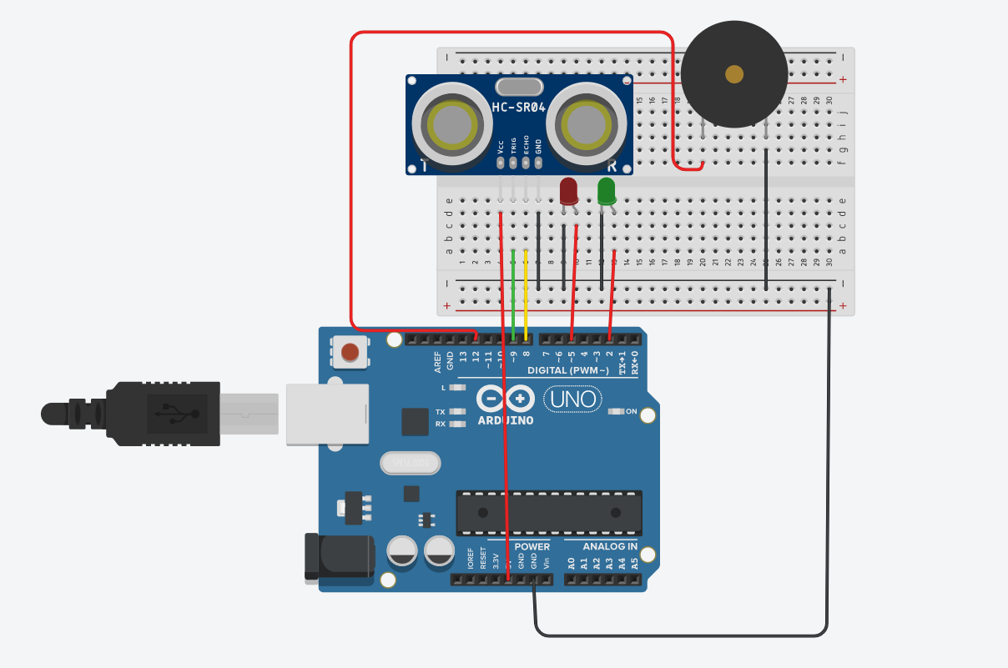

**Theory-**

**Concept Used**: In this question I used the concept of distance measuring with an Ultrasonic Sensor.  
When the box is closed, the distance between the lid and the sensor would be around 10cms. The only instance when the distance increases is when one opens the box.

**Learning & Observations:** We can use ultrasonic sensor to indicate if a gate or a lid is opened and it can be used in various other applications.

**Problems And Troubleshooting:**

Problem: I was going to use a LDR module for detection which would be way easier to implement but would not work in a dim environment hence the box would be non-functional in darker areas.

Troubleshooting: I instead used an ultrasonic sensor.

**Precautions:** There should be no obstacle between the sensor and the lid as it will result in false reading reporting.

**Learning Outcomes:**

* Learnt to update the sensor value without iterating the loop().
* Learnt that a separate function can be used to trigger the sensor.